**Effect of I-Beam Parameters on**

**Strength and Weight**

MATH 740 – Final Project

Nicholas Bealo

Kristopher Fargo

Erik Gustafson

Bradley Olsen

December 12, 2017

**Abstract**

**Methods and Materials**

Often it is necessary to determine the best combination of strength to weight. This ratio is a fundamental problem in engineering, with implications on the factor of safety and the cost of the product. This particular experiment was conducted to analyze the effect of beam dimensions on the strength and weight of the beam. To conduct this experiment, a full factorial design was selected with three continuous factors. The response was chosen to maximize the bearing load and minimize the weight. The specific factors chosen for this experiment are shown in Figure 1 below.

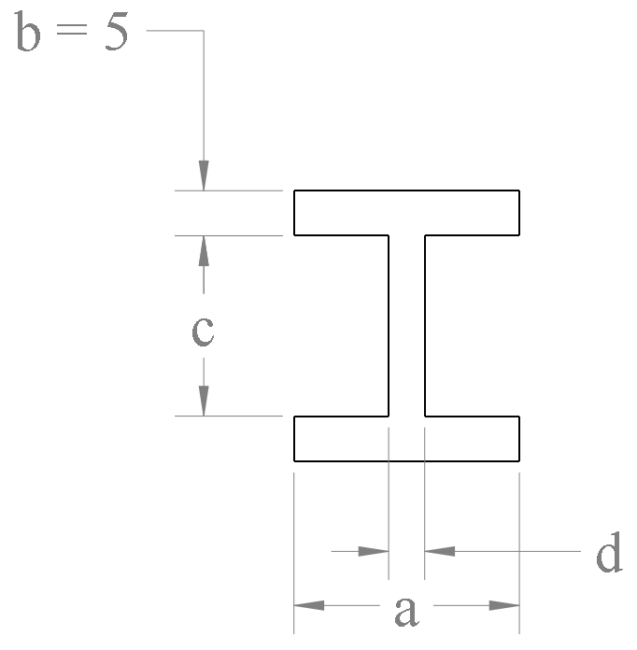

**Figure 1 - Beam Cross Section Factors**

For these four factors, a range of high and low values were provided. Note that dimension $b$ is held constant at 5 mm. The other factors were selected as shown in Table 1.

**Table 1 - Design Factors**

|  |  |  |
| --- | --- | --- |
| **Factor** | **Low Value** | **High Value** |
| a | 10 mm | 20 mm |
| c | 5 mm | 20 mm |
| d | 4 mm | 8 mm |

In order to test the factors above, the beam will be subjected to a distributed load until it yields. The load will be increased until yielding occurs as a function of the material properties. The setup for the testing is shown in Figure 2.

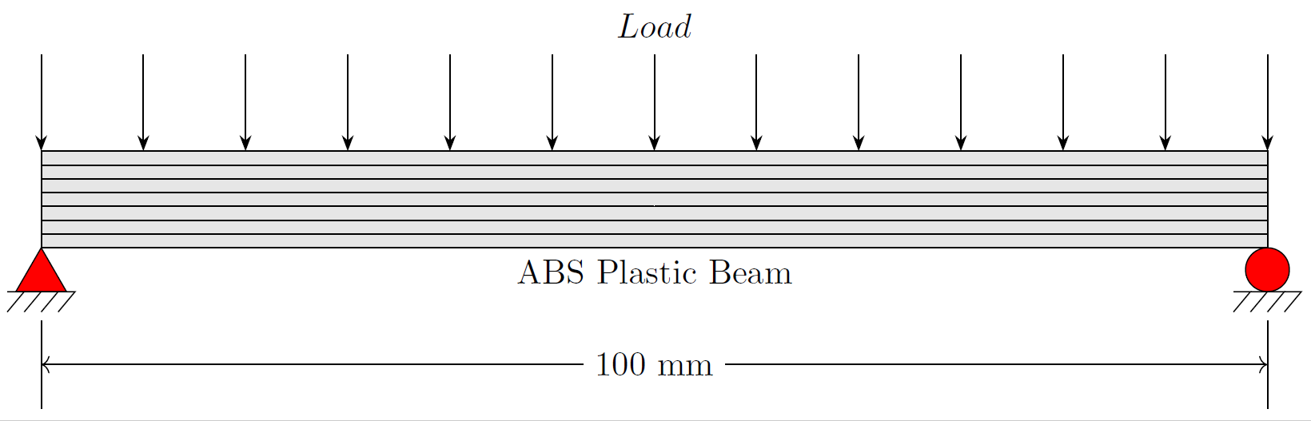

**Figure 2 - Beam Testing Configuration**

Using the testing configuration shown, the simply supported beam will be subjected to severe bending stresses at the midpoint of the span. Once these bending stresses exceed the material strength, the beam undergoes yielding, resulting in plastic deformation. The goal of this experiment is to maximize the load force until yielding occurs.

To help determine which of the factors above contributes the most to strength and weight, a response screening design was constructed using JMP. For this design, a custom DOE model was created with the responses and factors shown in Figure 3. The design also incorporated 12 randomized runs with no center points.

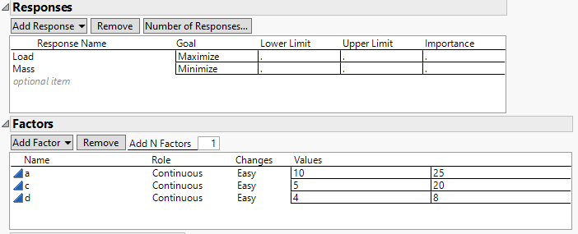

**Figure 3 - Custom Design Constraints**

For this design, pure orthogonality is desired, therefore the alias matrix output was checked.

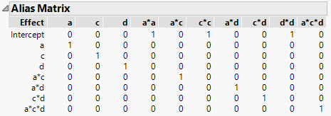

**Figure 4 - Design Aliasing Matrix**

With the custom design completed, the experimental responses were determined. It was intended that the various beam cross section options would be physically tested. To accomplish this, each of the designs were 3D printed and produced as shown in Figure 5.

A picture containing red, table

Description generated with very high confidence

**Figure 5 - 3D Printed Beams**

After handling the 3D printed parts, it became clear that testing them would be difficult. The stiffness of the beams exceeded our expectations. It was expected that the beams would yield at low load values, perhaps of between 1 to 10 kg, however the physical models were able to withstand substantially more load. In order to make progress with experimental results, the experimental results were obtained by other means. Instead of physical testing, the parts were analyzed in simulation using SolidWorks. For these simulations, the load was increased until yielding occurred. This provided a reliable experimental response to be used in response screening. An example of the simulation output can be seen in Figure 6.

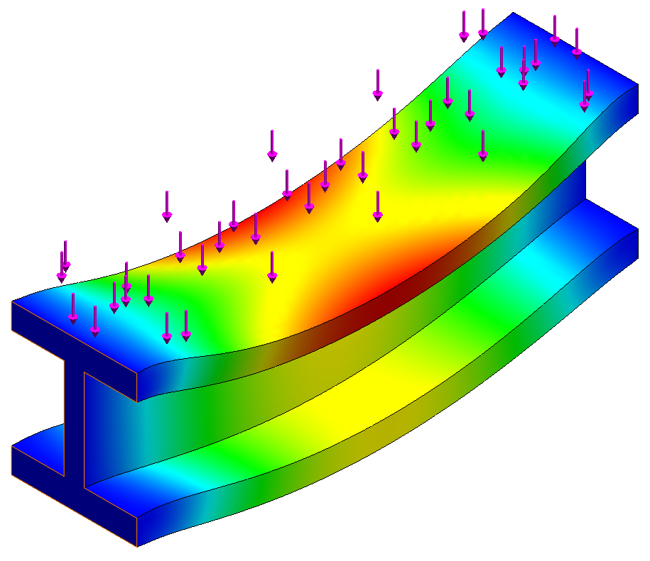

**Figure 6 - Simulated Stress Response**

One potential issue with using this approach is the deterministic nature of the simulations. Physical experimentation may involve significant amounts of noise and uncertainty. With the well-established analytical solution to beam stress, a governing equation could be used to determine the critical load at yielding. Nevertheless, the experimental analysis was still feasible and continued as planned.

Through the use of JMP, the model of the experiment was created alongside the custom design, resulting in a full factorial screening model. The model was fit for the two responses, maximized load and minimized mass, and their respective factor contributions.

**Results**

**Confirmatory Trials**

**Conclusion**